Instruction:

Complete all questions in 1 hour.

1. Differentiate between Data and Information.

|  |  |
| --- | --- |
| Data | Information |
| Data refers to raw facts and figures. | Information is the processed and organized form of data. |
| Data is unorganized and unprocessed. | Information is structured and meaningful. |
| Data can be numerical, textual, or visual. | Information is a combination of different types of data. |
| Data is a collection of facts and statistics. | Information is knowledge that can be used to make decisions. |

1. Write short notes on:
2. DBMS

* A DBMS (Database Management System) is a software system that is used to manage and organize data in a database. It allows users to create, update, retrieve, and delete data in a structured and efficient way. DBMSs provide a variety of tools and features such as data security, data integrity, data recovery, and data access control. They also allow for easy data sharing among multiple users and applications. Some popular examples of DBMS include MySQL, SQL Server, and Oracle. DBMSs are widely used in various industries such as finance, healthcare, and e-commerce.

1. SQL

* SQL (Structured Query Language) is a programming language that is used to manage and manipulate data in a relational database management system (RDBMS). It is used to perform operations like inserting, updating, retrieving and deleting data from a database. SQL is a standard language for interacting with relational databases. It is used to create, modify and query tables and other database objects. Some of the common operations that can be performed using SQL include SELECT, INSERT, UPDATE, and DELETE. SQL is widely used in various industries, including finance, healthcare, and e-commerce. It is also used for data warehousing and business intelligence applications.

1. File System

* A file system is a method for storing and organizing computer files and the data they contain to make it easy to find and access them. A file system organizes files into a tree-like structure, which is called the directory structure, with a root directory at the top. The file system determines how data is stored on the disk, how files are named and where they are placed physically on the disk. Examples of file systems include NTFS, FAT32, and ext4. The file systems also provide features like file permissions, encryption, compression and backup. File systems also contain metadata about the files, such as timestamps for creation and modification, and the file's owner and permissions, which are used by the operating system to manage access to the files.

1. Download and install XAMPP from any browser.

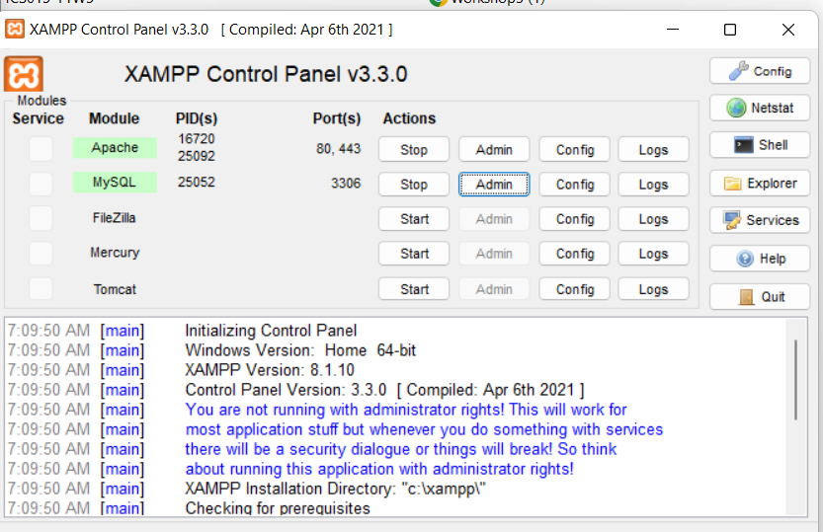

1. Create a database named HCK.

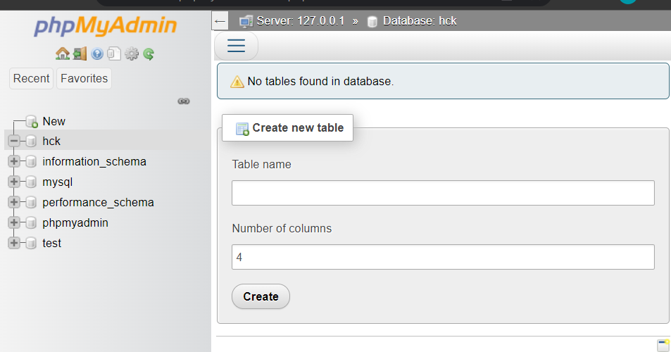

1. Create tables named Students, Parents and Tutors.

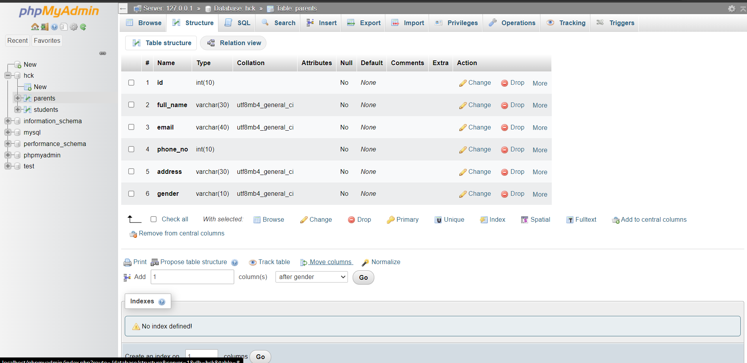

1. Create the attributes like (id, full_name, email, phone_no, address and gender) in all the above tables with suitable data types.

1. Insert the data using SQL Commands in all the table. (3 data)

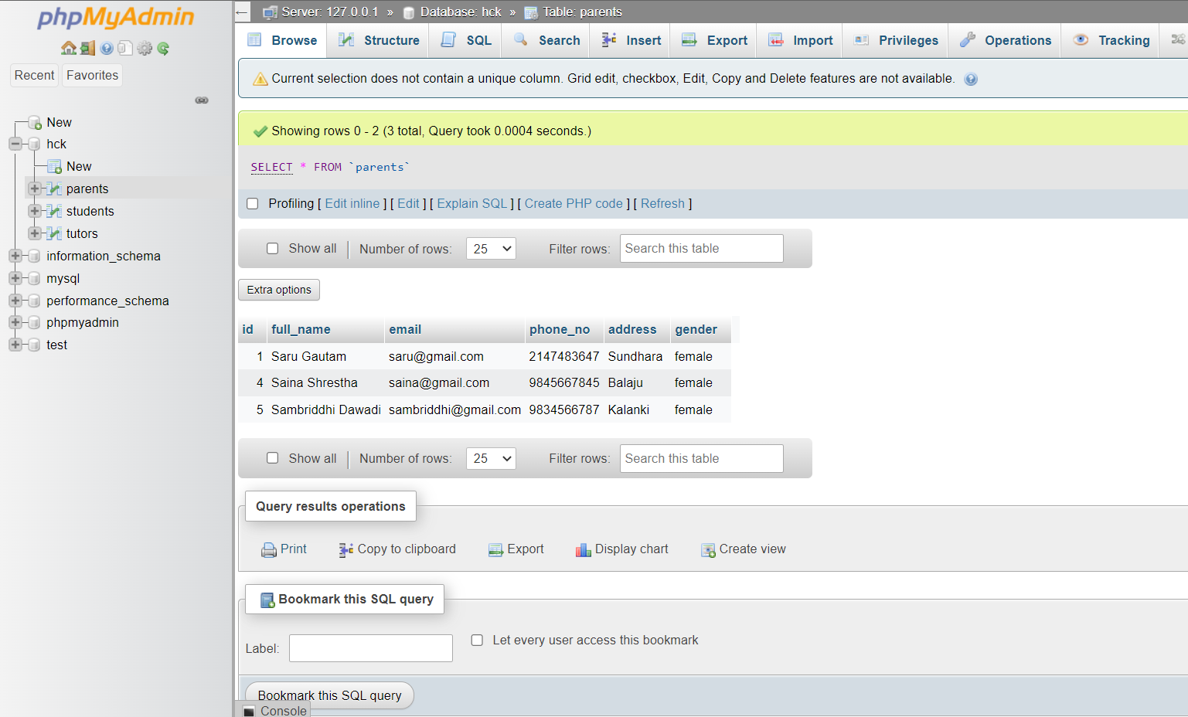

1. Display the all data of the table Tutors.

1. Display only male students from table Students.

1. Drop column Parents using SQL command.

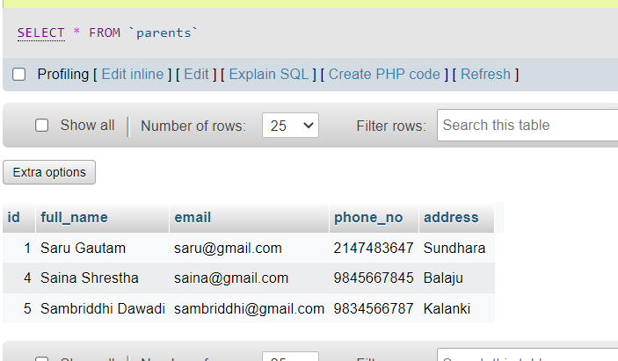

1. Delete a row in student using SQL command.

